2c – Camera movement
Camera movement | Description | Example
Tilt | Moving the camera’s lens up or down while tripod remains in the same position. | 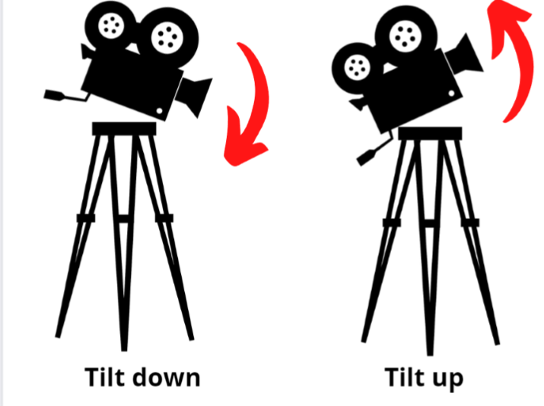
Pan | Moving the camera lens from left to right or right to left. | 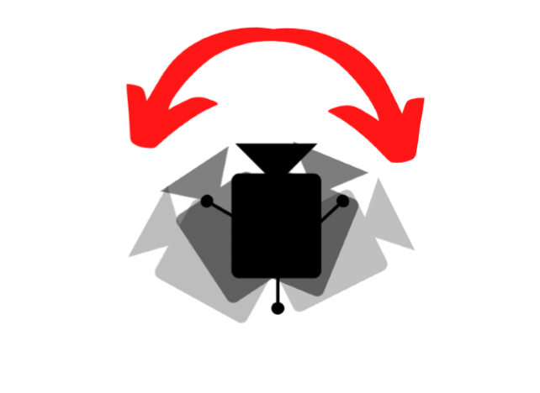
Zoom | Changing the focal length of the lens to make the subject appear closer or further away in the frame. | 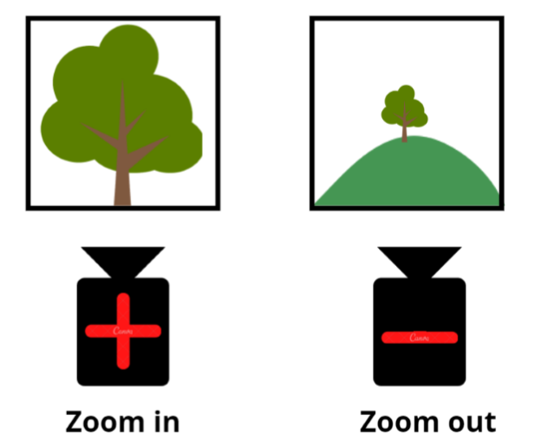
Pedestal | Moving the camera up or down without tilting. This can be achieved by raising or lowering the tripod head. | 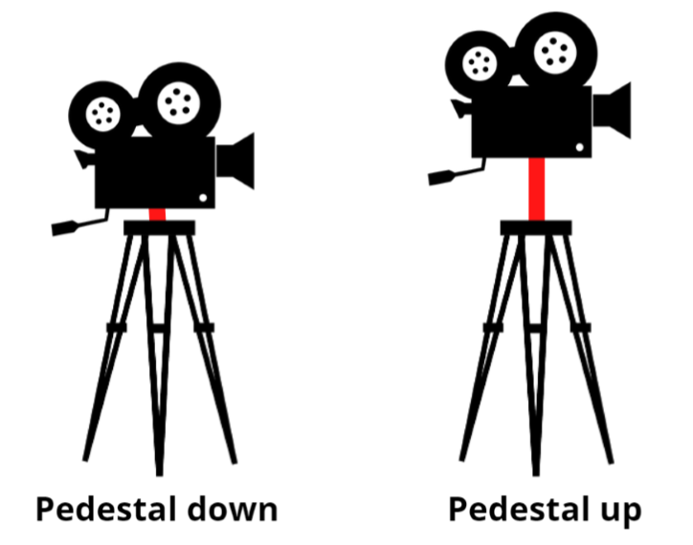
Dolly | Moving the camera towards or away from the scene you are filming. The whole camera set up is moved usually on a platform with wheels or tracks. | 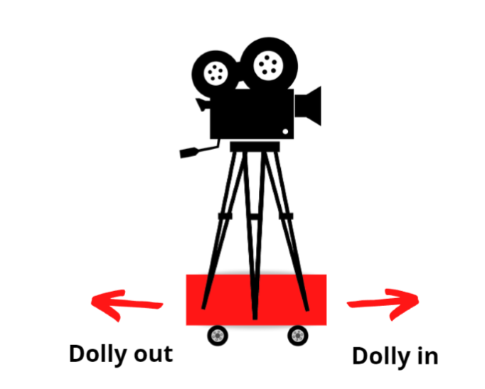
Truck | Moving the camera left or right while keeping the same distance from the scene being recorded. The whole camera set up is moved, usually on a platform with wheels or tracks. | 