2c – Shot type examples
Shot name | Abbreviation | Description | Example
Wide shot  Extreme wide shot  Establishing shot | WS  EWS  ES | A wide-angle shot where the features of the location are clearly visible. If the subject is in the shot, their whole body will usually be visible.  Often used as establishing shots to set the scene or describe the location. | 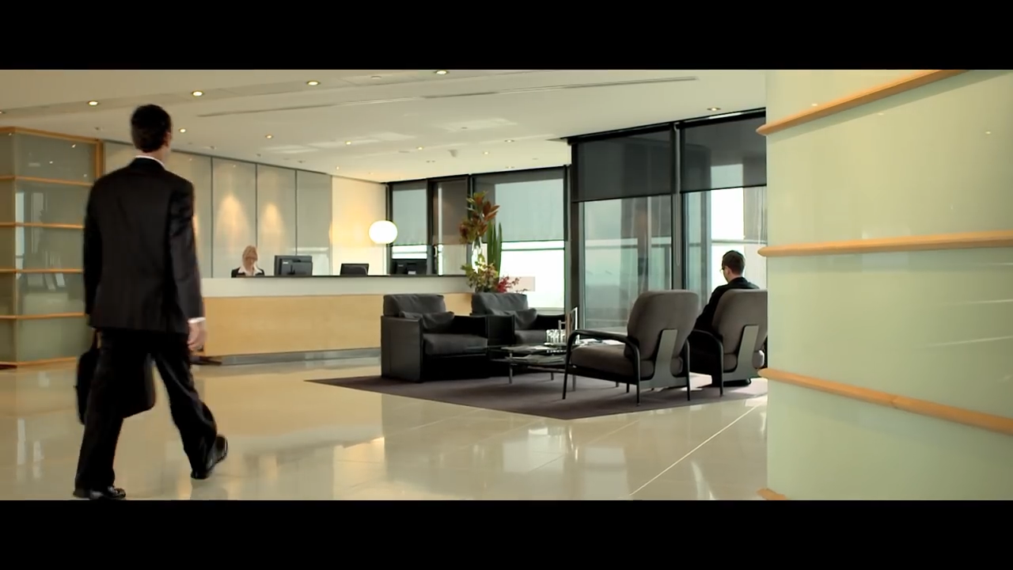
Medium shot  Mid shot | MS | These types of shots focus on the subject, but also show part of the background.  Mid shots often show the subject from the waist up. | 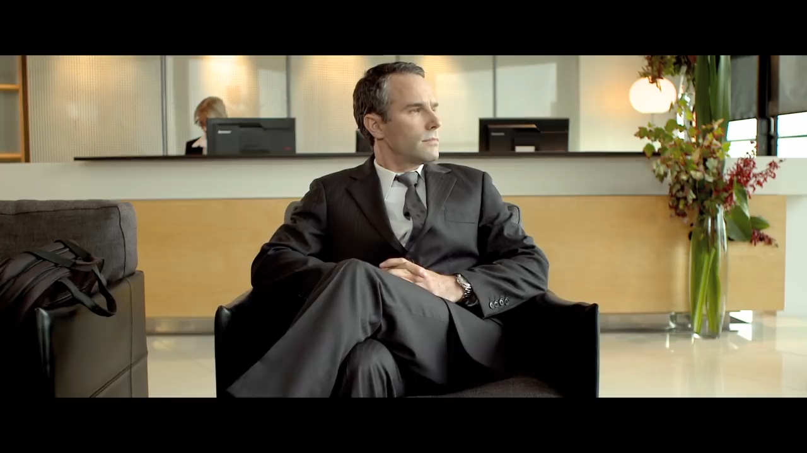
Close-up  Extreme Close up | CU  ECU | Close-ups usually show the subject’s face and are often used to communicate an emotional response.  An extreme close-up exaggerates this effect by only showing part of the face. | 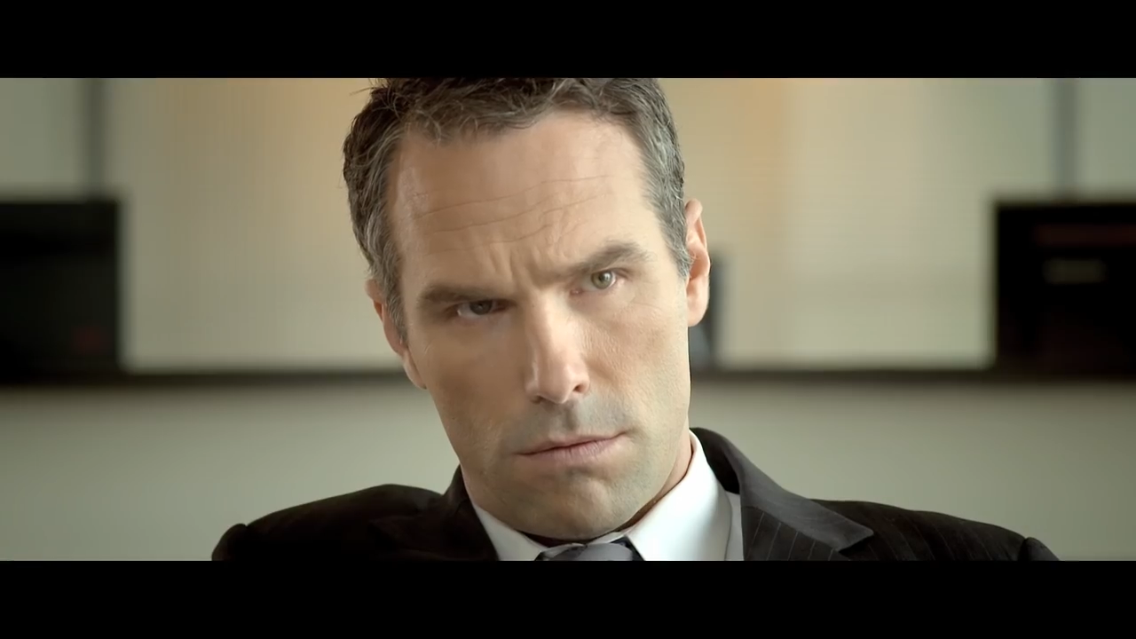
Over the shoulder | OTS | Often used in dialogue scenes to show the physical proximity of two characters.  The camera is set up facing one character, with the back or shoulder of another character visible in the frame.  Usually a medium or close-up. | 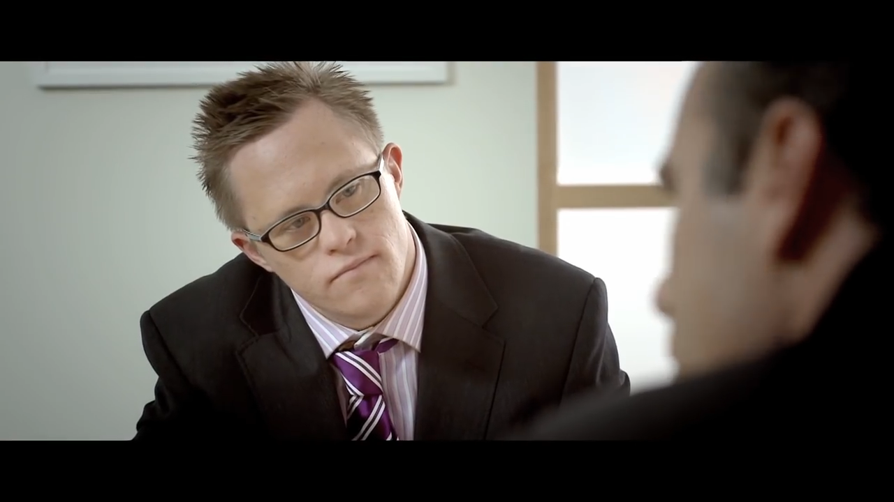
Cutaway | CA | A cutaway is an extra show that ‘cuts away’ from the main shot to show something else. Cutaways can be used to give additional context to a scene or to show something that is being referred to in the dialogue. Cutaways are often used for comedic effect or to establish dramatic irony.  Cutaways can be used to transition between scenes, to describe a change in location or the passage of time. | 