2c – Camera angles
Shot name | Abbreviation | Description | Example
Over the shoulder shot | OS | The camera is placed over the shoulder of a character in a conversation with another character. This is the most common way to get coverage in a conversation. | 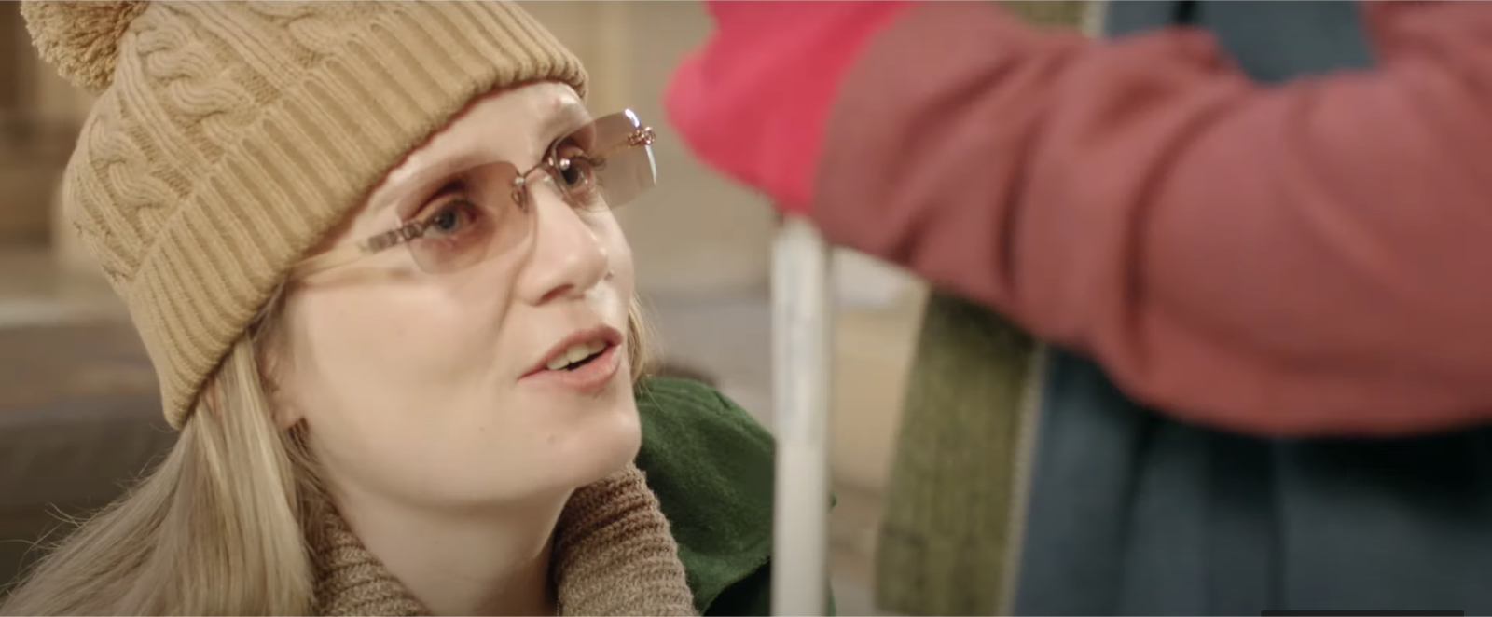
Reverse over the shoulder shot | ROS | As above, but you are covering the other character in conversation.  OS and Reverse OS are also known affectionately as ‘roundy roundies!’ | 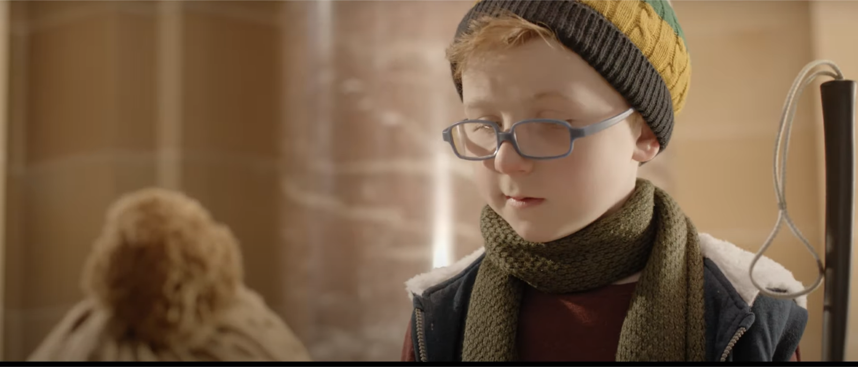
Eye level | EL | The camera is placed roughly in line with the subject’s eyes. This is a neutral angle. | 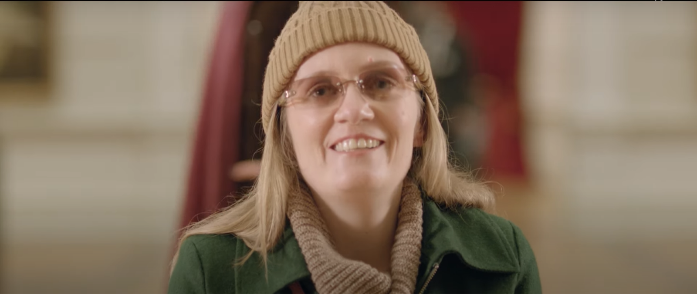
High angle | HA | The camera is placed above the subject, looking down.  This is used for a specific effect, to make the subject seem smaller or give a point of view. | 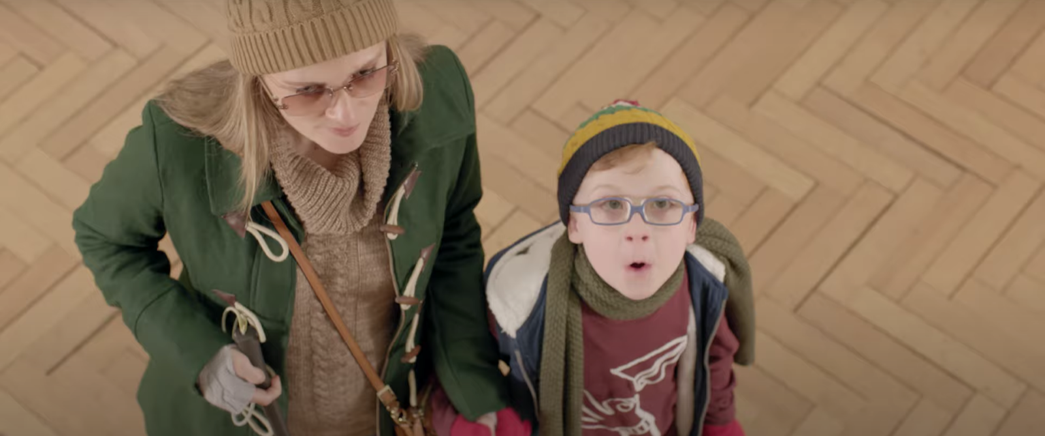
Overhead  Bird’s eye | OBE | The subject is shot from directly above. This is used for a specific effect. Overhead shots of table settings are a common example and allows for a strong aesthetic/ compositional choice. | 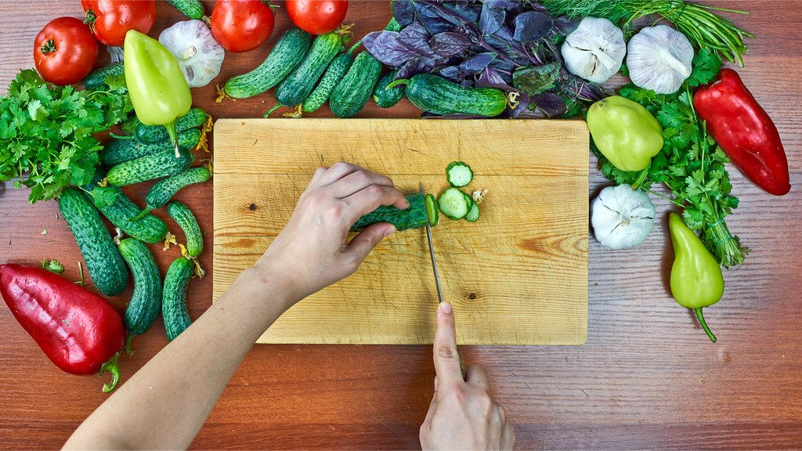
Low angle | LA | The camera is placed below the subject’s eye-line, looking up. This is used for a specific effect, to make the subject seem larger or give a point of view. | 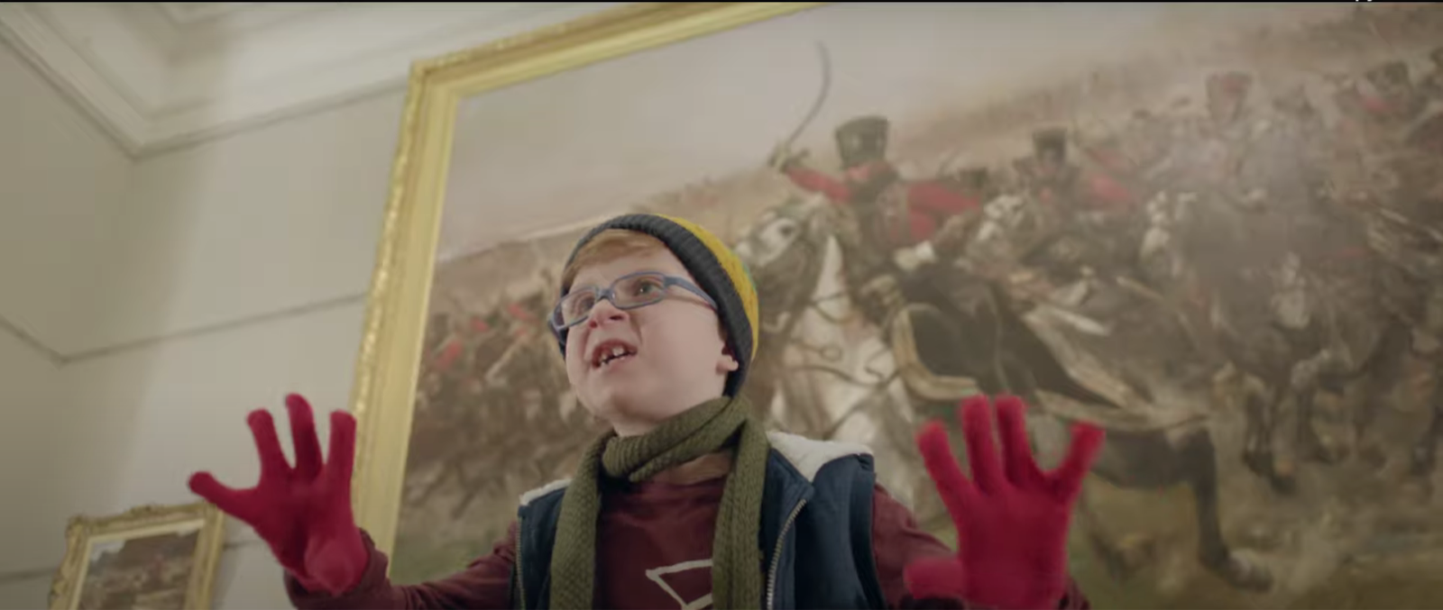
Extreme low angle or Worm’s eye | ELA | The camera is placed extremely low and looks almost directly up. This is used for a specific effect or to give a point of view. | 
Tilt or  Dutch angle | T | The camera is tilted at an unusual angle. It is used for a specific effect and usually connotes disorder or disruption, or a character’s point of view. Generally, these should be used very sparingly. | 
Point-of-view | POV | This angle is used for specific effect to give a subject’s perspective. This may be used as a variation on an over the shoulder shot. For example, to show a first-person view of someone texting or writing. It could be taken to an extreme to show a whole scene or film from a first-person perspective. | 
Compartment shot | CS | Placing the camera in a container like a fridge, cupboard or suitcase, which opens to reveal the subject as they open the container. | 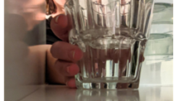
Attributions:
- Genevieve Clay-Smith (2017) Inclusion makes the world more vibrant [video stills] accessed 21/07/2022
- Mahbub Hasan. Overhead view of a woman slicing raw cucumber on cutting board [image] accessed 02/06/2022. Image example in ‘overhead birds eye’ row.
- Marco Verch (2018) Tilted shot of theatre royal drury lane in london [image] accessed 02/06/2022. Image example in ‘tilt or dutch angle’ row.

